Contents
Core Components of the SDL Pipeline 3
Design (AI & Optimization Planners): 3
Build (Robotic Hardware & Synthesis Layer): 3
Test (Automated Characterization & Sensors): 3
Learn (Orchestration Software & Closed-Loop Feedback): 3
Human-in-the-Loop (Governance & Architecture): 3
U of T and SDL: 4
Acceleration Consortium at the University of Toronto 4
University of Toronto SCS Certificate: Introduction to AI for Discovery Using Self-Driving Labs 5
The top five things you need to know about how SDLs are changing the way materials are discovered: 5
Regulatory Framework 7
10 Guiding Principles of Good AI Practice in Drug Development 7
Industry Components 8
Self-Driving Labs in 2026 - What Actually Works vs. What's Still Hype 8
Royal Society Open Science – scale for laboratory automation 8
The Software Gap – Why Middleware Is the Real Bottleneck 9
Key Suppliers in SDL 10
Atinary Technologies 10
Automata 10
Strateos 10
Chemify 11
Mita Chem 11
Dunia Innovation 11
LabGenius 11
Insilico Medicine 12
Users Guide to First Self Driving Handling Lab 13
PDF: 13
Closed Loop vs. Autonomous System 13
Link 13

Core Components of the SDL Pipeline

Design (AI & Optimization Planners):
  - Uses machine learning models, active learning, Bayesian optimization, or evolutionary algorithms to propose the next set of experiments based on past data.
  - Translates high-level objectives and chemical/biological descriptors (such as SMILES or SELFIES) into concrete experimental parameters. [1, 2, 3, 4]

Build (Robotic Hardware & Synthesis Layer):
  - The physical execution layer containing automated liquid handlers, continuous flow reactors, or mobile robotic arms.
  - Synthesizes materials, mixes compounds, or prepares biological assays autonomously. [1, 2, 3, 4, 5, 6]

Test (Automated Characterization & Sensors):
  - Instruments such as UV-vis spectrophotometers, UPLC, AS-MS assays, or IoT-enabled light sensors measure the physical or chemical results.
  - Cameras and non-destructive biosensors stream real-time data back into the system. [1, 2, 3, 4, 5, 6]

Learn (Orchestration Software & Closed-Loop Feedback):
  - Orchestration software (such as ChemOS or SiLA2) and master schedulers coordinate instrument control, data logging, and safety protocols.
  - Experimental results are fed back into the surrogate models to update predictions and trigger the next iteration. [1, 2, 3, 4, 5, 6]

Human-in-the-Loop (Governance & Architecture):
  - Human scientists act as system architects—defining search spaces, setting high-level goals, and providing critical oversight or mechanistic analysis

U of T and SDL:

Acceleration Consortium at the University of Toronto
Source: Acceleration Consortium at the University of Toronto is a global hub for SDL research pioneering, modular discovery platforms and offering specialized training (like the Autonomous Systems for Discovery Certificate)
Self-driving laboratories (SDLs) are automated research systems that merge artificial intelligence (AI), machine learning, robotics, and advanced reactor engineering into a continuous, closed-loop workflow
https://acceleration.utoronto.ca/what-is-an-sdl (acceleration consortium)

- Design: AI and Bayesian optimization or active learning algorithms generate candidate molecules, formulations, or materials.
- Make: Autonomous robotic platforms, fluidic handlers, or 3D-printed gantry systems synthesize the material.
- Test: Automated instruments and sensors evaluate physical or chemical properties in real time.
- Analyze & Learn: Data feeds back into the AI model, updating the parameter space to select the next most informative experiment.

Introduction to AI for Discovery Using Self-Driving Labs (from Sterling Baird)

University of Toronto SCS Certificate: Introduction to AI for Discovery Using Self-Driving Labs
https://learn.utoronto.ca/curiousu-blog/curiosity/what-self-driving-lab-five-things-you-need-know-about-future-materials
COMMENTS – contains good content as to what business problem we are seeking to solve
Materials have the potential to transform our lives and our world for the better. However, the current materials discovery process is slow and expensive- taking decades and hundreds of millions of dollars to achieve a successful result.
The University of Toronto’s Acceleration Consortium is using self-driving labs (SDLs) to make new materials cheaper and faster while remaining committed to ethical design principles.
Here are:

The top five things you need to know about how SDLs are changing the way materials are discovered:
1. SDLs invert the usual discovery process by starting with the desired outcome
Traditionally, when scientists are working with a new material, they start by trying to figure out what a material they have made can do.
With inverse design, they start with what they want the material to be able to do and then work to discover a material that accomplishes those objectives.
2. SDLs combine artificial intelligence, robotics, and advanced computing to rapidly design and test new materials
Once scientists tell the SDL’s artificial intelligence and computational modelling systems which properties they are looking for in a new material, the AI will use existing data to predict which new materials will fit those criteria. A robotic lab then uses these predictions to autonomously synthesize and test the candidate materials. This test data is then fed back into the AI so that it can learn from the results to generate a new, better materials. This will continue in a closed loop system until the new material is discovered.
3. By using SDLs, materials development time is shortened by an order of magnitude
Once they are set up, SDLs save scientists hours of tedious trial and experiments in the lab which reduces discovery time down from decades to years or even weeks! SDLs have already been used to discover new organic lasers and new drug formulations.
4. Many scientific fields can use SDLs for discovery. The chemical space is huge, almost too big for any one person to imagine. Scientists estimate there are billions of materials out there just waiting for us to discover and we have only scratched the surface. SDLs allow researchers to explore more options faster in fields like drugs and formulations, alloys, batteries, plastics, and wearable technology.
5. You can learn more about SDLs through the School of Continuing Studies
The School of Continuing Studies offers an Autonomous Systems for Discovery Certificate that will prepare you to use SDL tools and technology. The first asynchronous and remote course, Introduction to AI for Discovery Using Self-Driving Labs, is available for registration now.

Some pure-play SDL software & orchestration platforms

- Atinary Technologies: A pioneer in SDL software, commercializing its SDLabs platform. It provides no-code machine learning algorithms that connect directly to laboratory robotics to autonomously optimize complex chemical reactions and material formulations. [1]
- Automata: Highly successful in commercializing lab orchestration hardware and software through its LINQ platform. It acts as a universal physical and digital bridge, allowing multi-vendor instruments to run fully automated, repetitive, or closed-loop diagnostic and research workflows

Regulatory Framework

10 Guiding Principles of Good AI Practice in Drug Development
Developed by the FDA and EMA
https://www.continuousintelligence.ai/blog/ai-governance-gxp-fda-ema-guiding-principles

Industry Components

Self-Driving Labs in 2026 - What Actually Works vs. What's Still Hype
https://qpillars.com/blog/self-driving-labs-2026-what-works-vs-hype

Royal Society Open Science – scale for laboratory automation
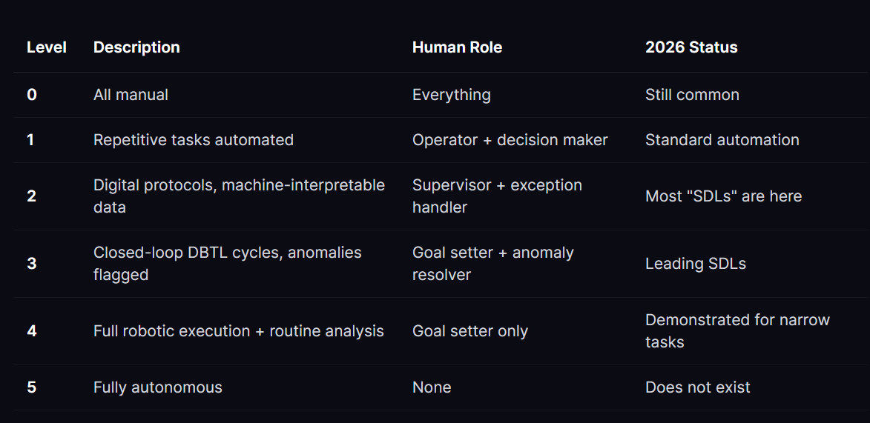

The Software Gap – Why Middleware Is the Real Bottleneck
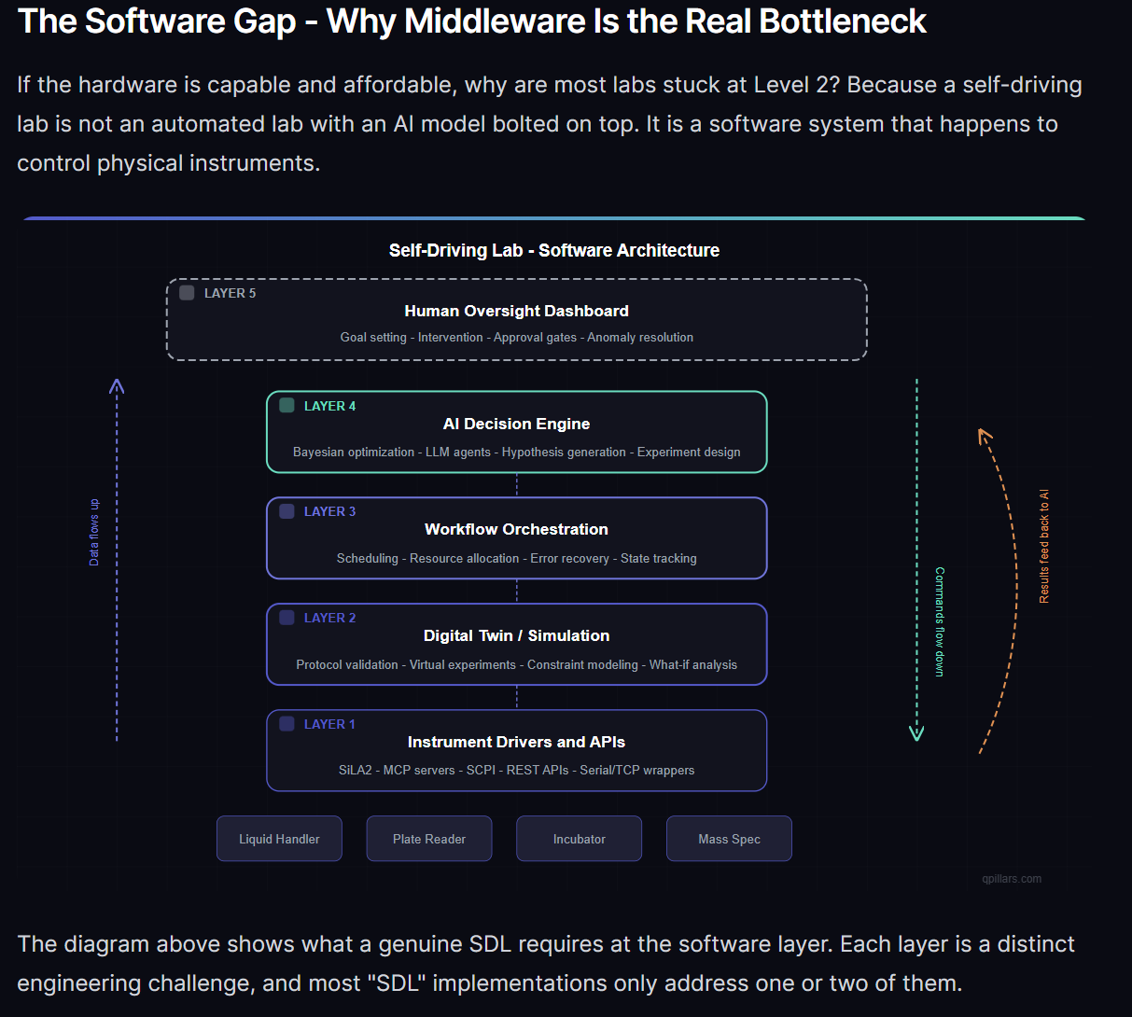
https://qpillars.com/blog/self-driving-labs-2026-what-works-vs-hype

Key Suppliers in SDL
In the domain of Self-Driving Labs (SDLs)—also known as autonomous laboratories or closed-loop R&D platforms—commercialization has transitioned from academic proof-of-concepts to viable physical products, cloud services, and chemical outputs. Rather than self-driving cars, these companies commercialize AI-driven, robotic architectures that design, execute, and analyze physical chemistry and biology experiments without human intervention. [1, 2, 3, 4]
The key commercial players are categorized below by their business models:
1. Pure-Play SDL Software & Orchestration Platforms
These companies commercialize the "brain" and middleware of the self-driving lab. They sell software that integrates legacy lab hardware with machine learning loops to orchestrate autonomous experimentation. [1, 2]

Atinary Technologies
- Atinary Technologies: A pioneer in SDL software, commercializing its SDLabs platform. It provides no-code machine learning algorithms that connect directly to laboratory robotics to autonomously optimize complex chemical reactions and material formulations. [1]

Automata
- Automata: Highly successful in commercializing lab orchestration hardware and software through its LINQ platform. It acts as a universal physical and digital bridge, allowing multi-vendor instruments to run fully automated, repetitive, or closed-loop diagnostic and research workflows. [1, 2]
2. Autonomous Cloud Labs (Lab-as-a-Service)
These companies have commercialized the entire infrastructure by building massive, highly automated physical facilities that clients program remotely via the cloud. [1]

Strateos
- Strateos and Emerald Cloud Lab (ECL): Both have commercialized the Robotic Cloud Lab model. Scientists input an AI-driven experimental design over the internet, and remote, software-controlled automated facilities handle the physical execution, generating structured data streams directly back to the user. [1]
3. Vertical SDLs: Advanced Materials & Chemicals
These companies use proprietary self-driving labs internally to discover, manufacture, and sell advanced physical materials, moving entirely past selling software to sell actual chemical assets. [1]

Chemify
- Chemify: Spun out of the University of Glasgow, Chemify has commercialized a proprietary digital chemistry platform. It codifies chemical blueprints into computer program code ("chemputing") to allow automated robotic synthesis engines to produce novel small molecules on demand. [1]

Mita Chem
- Mitra Chem: Uses an internal, highly automated, closed-loop machine learning lab to drastically compress the R&D cycle for battery cathode materials. It bypasses traditional decades-long synthesis timelines to bring market-ready battery cells to commercial clients. [1, 2]

Dunia Innovation
- Dunia Innovation: Focuses on clean energy and electrochemistry. They have successfully commercialized a closed-loop Design-Make-Test-Analyze platform that discovered advanced, high-performance catalyst inks for green hydrogen production far faster than human workflows. [1]
- ChemLex Technology: Based in Singapore, ChemLex commercializes a 24/7 autonomous chemical synthesis line. It provides contract physical AI-driven synthesis services to global pharmaceutical and materials discovery firms. [1, 2]
4. Vertical SDLs: Biotech & Antibody Discovery

LabGenius
- LabGenius: A prime example of an operational Level 4 autonomous bio-lab. It has commercialized an internal closed-loop machine learning platform (EVA) that autonomously designs, conducts, and learns from protein engineering experiments to find novel therapeutic antibodies. [1, 2]

Insilico Medicine
- Insilico Medicine: Widely recognized for bridging generative AI with its physical Sixth Generation Autonomous Robotics Lab, running closed-loop target discovery and fully automated compound synthesis for clinical drug pipelines. [1]

Users Guide to First Self Driving Handling Lab
PDF: https://pubs.rsc.org/dd/article/5/5/2028/1239318/A-user-s-guide-to-your-first-self-driving-liquid

Closed Loop vs. Autonomous System
Autonomous uses AI – persists running even
A .1% fail rate is enough to affect performance
Human is elevated to system architecture outside of the system. Scientist elevates to setting high level optimization goals and defines the search space from which to achieve the goal.
Link: https://www.youtube.com/watch?v=_uyFHvC5Tvc

